1. Roaster Management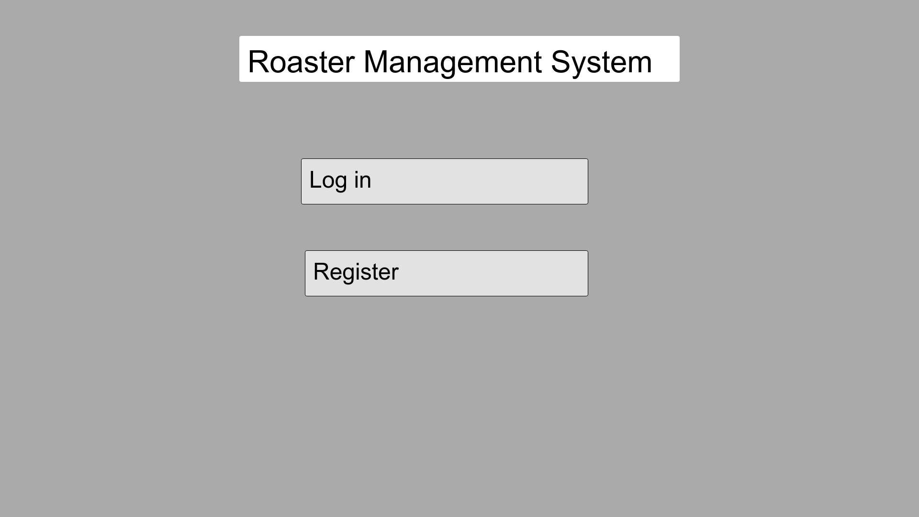

|  |  |
| --- | --- |
| Description | This is the first page of application. User with existing account can login. User who does not have account can register to create account |
| Content | Roaster management system, Log in, Registration |
| Navigation | The login button redirect user to login page. If staff sign in, then it lead user to users’ dashboards as if admin sign in, it redirects to admin dashboards |
| Graphics | Company logo on top left side |

2.Log in

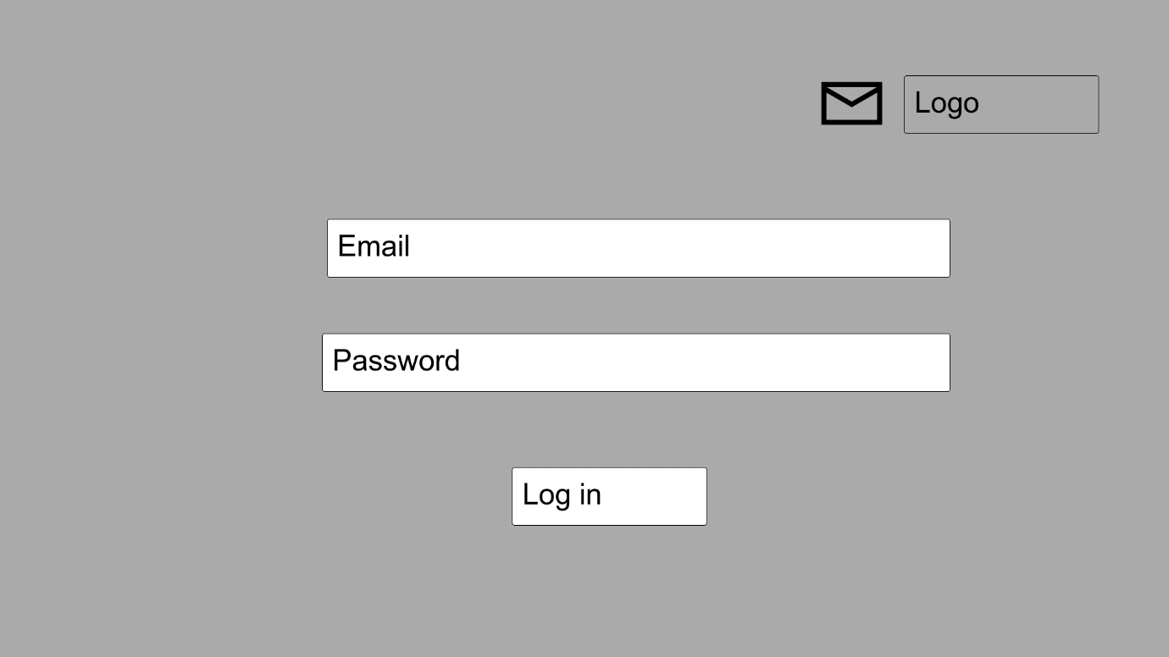

|  |  |
| --- | --- |
| Description | User can sign in with their email and application which lead to dashboard |
| Content | Email, Password, Log in |
| Navigation | If details are correct, it will lead user to dashboard. If email or password is incorrect, it will say invalid email or password, then users need to enter the correct details |
| Graphics | Company logo on the top left side |

3.Registration

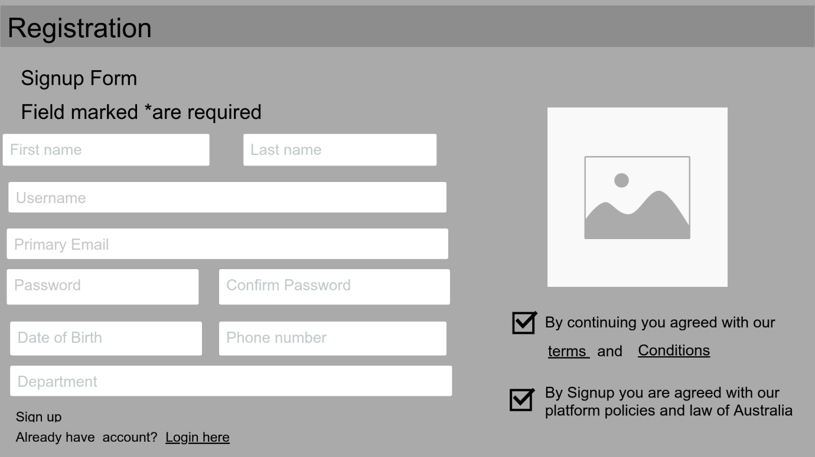

|  |  |
| --- | --- |
| Description | This is the sign-up page for the new users. Users need to enter all required fields to create an account. By signing up here, users agreed with terms and condition of the company and also the platform policies and law of Australia |
| Content | First name, Last name, User name, Primary email, Password, Confirm password, Date of birth, Phone number, Department |
| Navigation | Clicking register in the first page of the application redirect users on this page. User can view all policies of company by clicking terms and conditions, On the right side of bottom of the page, there is login link for the existing users. |
| Graphics | Company logo on the top left side |

4.Homepage

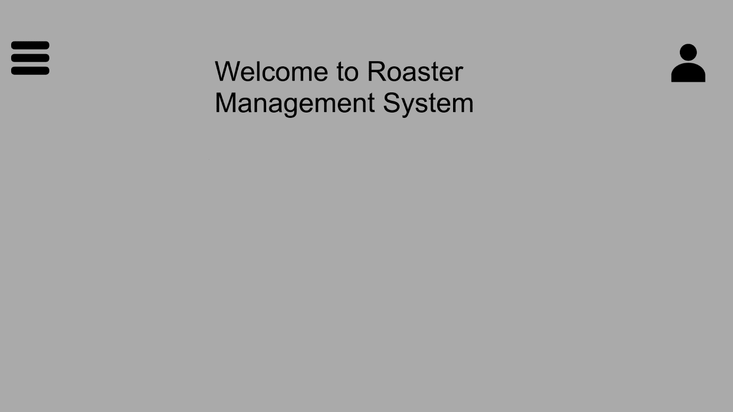

|  |  |
| --- | --- |
| Description | This is homepage. After login, user will redirect to user homepage as if admin log in, it will redirect to admin homepage |
| Content | Welcome to Roaster Management System |
| Navigation | By clicking on menu on top right side, user can access to different page |
| Graphics | Company logo on top left side |

5. Dashboard

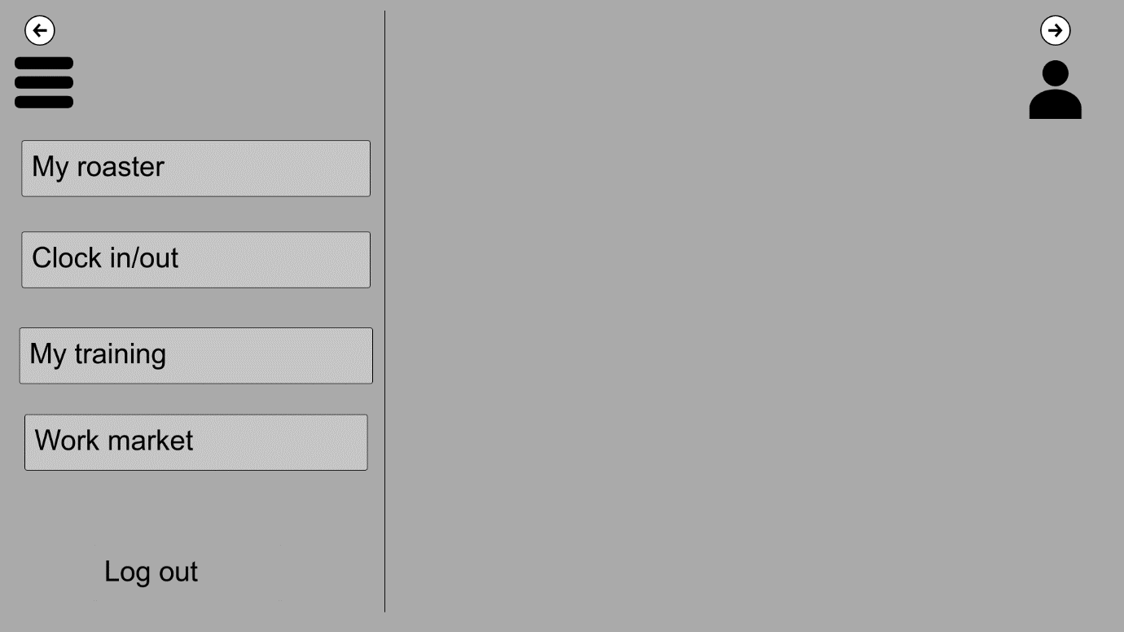

|  |  |
| --- | --- |
| Description | By clicking menu on top right side, user can view roaster, clock in/out, staff training and work market |
| Content | Roaster, Clock in/out, my training, Work market, log out |
| Navigation | By clicking each main page, user can view details of their work history, training |
| Graphics | Company logo on top left side |

6. Profile

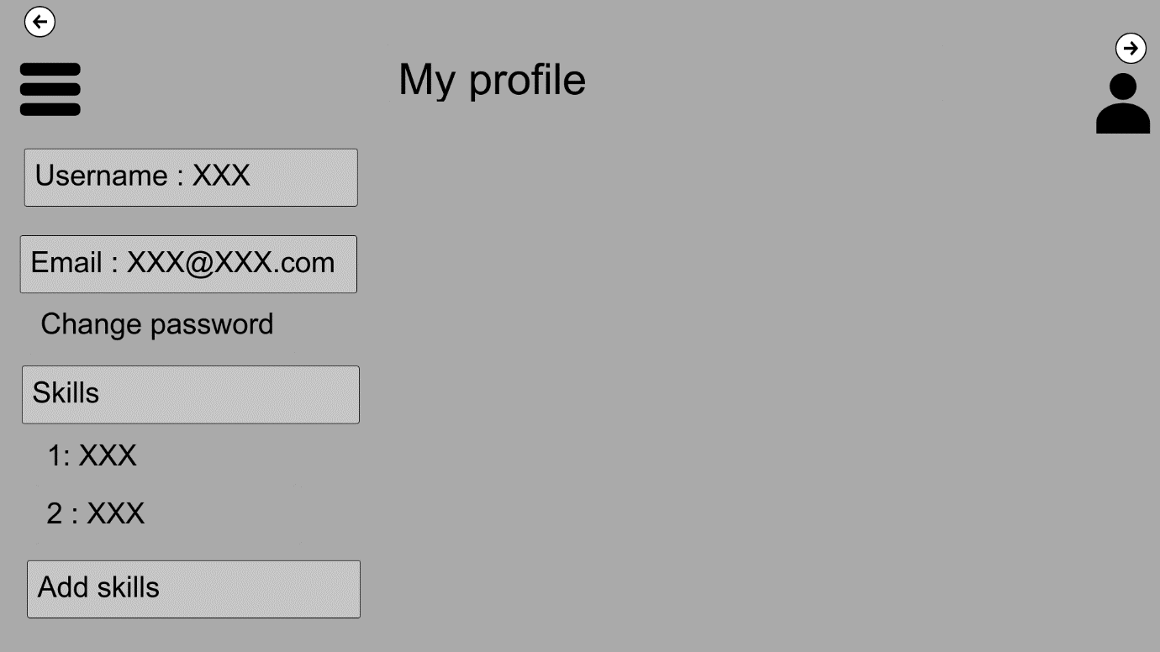

|  |  |
| --- | --- |
| Description | Clicking on profile bottom of top left side will redirect user to this page. |
| Content | Username, Email, change password, Skills, Add skills |
| Navigation | Clicking on each bottom will let user edit their information |
| Graphic | Company logo on top left side |